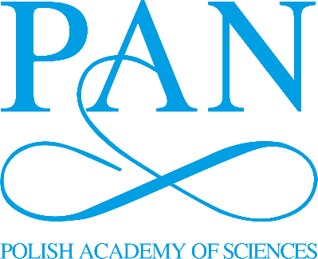
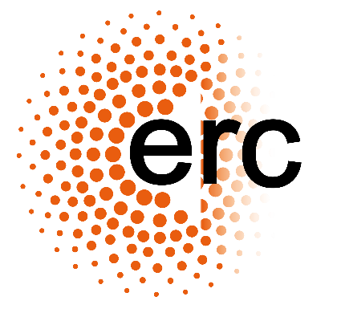

European Research Council (ERC) grants: information session
20 April 2023, 10:00 am – 12.30 pm, online
Excellence in Science Department, Polish Academy of Sciences

10:00 – 10:10 | What should you know about ERC funding? | dr Piotr Potocki

10:10 – 10:25 | ERC grants: a recipient’s perspective | dr Agnieszka Brylak  University of Warsaw

10:25 - 10:50 | Types of ERC grants | dr Anzhalika Litvinovich
 | Break

11:00 - 11:55 | Preparing an ERC proposal | dr Piotr Potocki  Katarzyna Książczyk

11:55 - 12:15 | ERC grants: a panel member’s perspective | prof. dr hab. Alicja Józkowicz  Jagiellonian University

12:15 - 12:30 | Q&A session

